_______________________________________________________________________
NAME: MUHAMMAD UZAIR WAHEED
ROLL NO: 242780

Task 1 — Courses Module: Services, Providers and Tokens
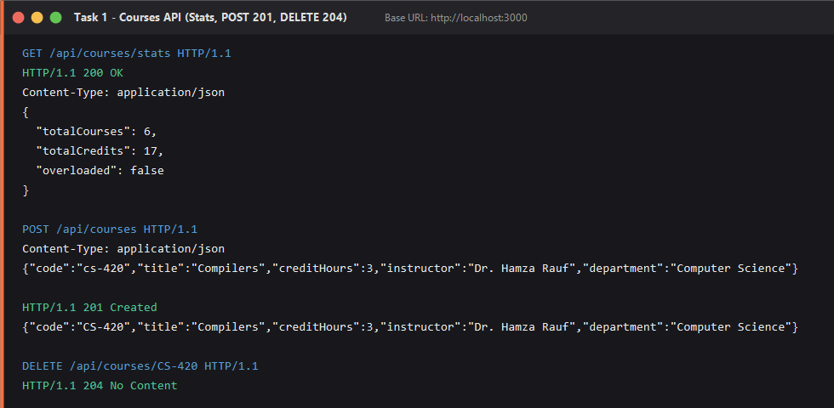
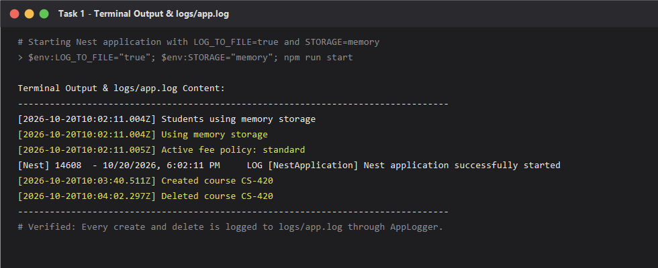

Task 2 — Pluggable Fee Policy (Custom Providers)
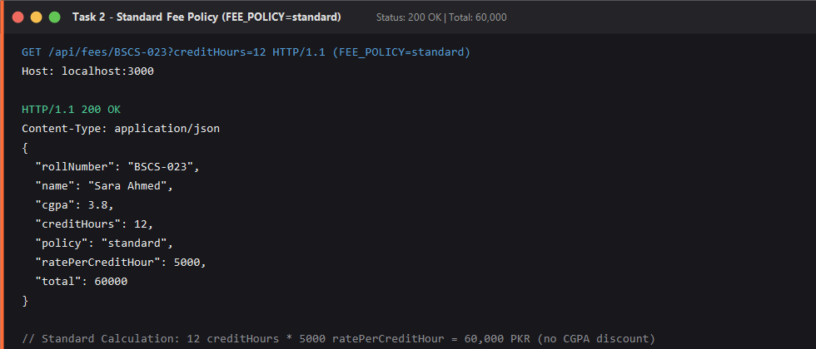
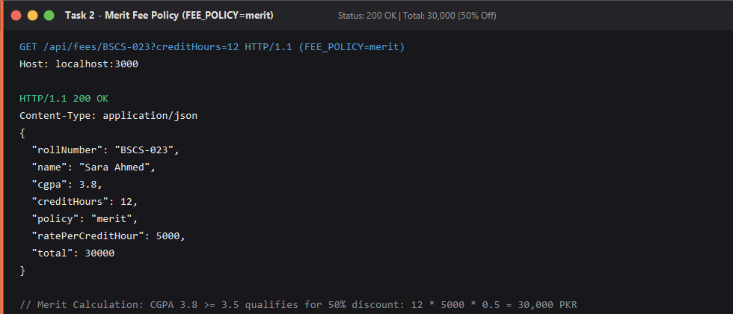

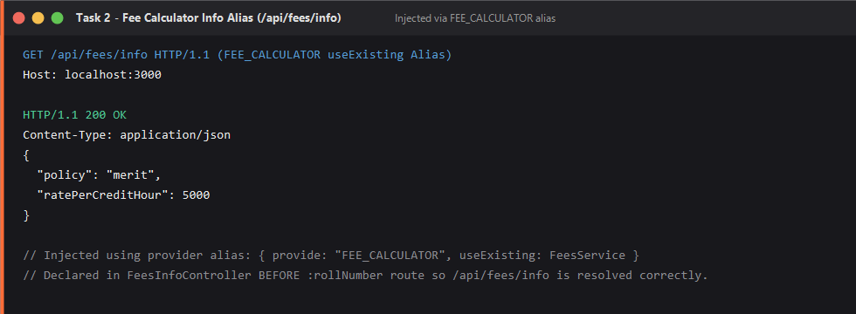

Task 3 — DTOs and Validation
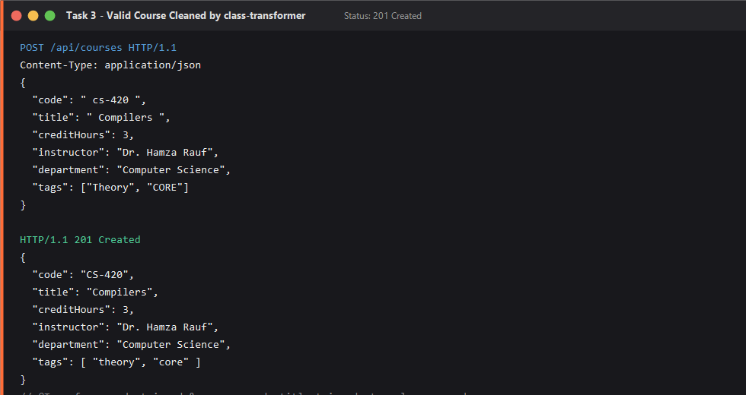
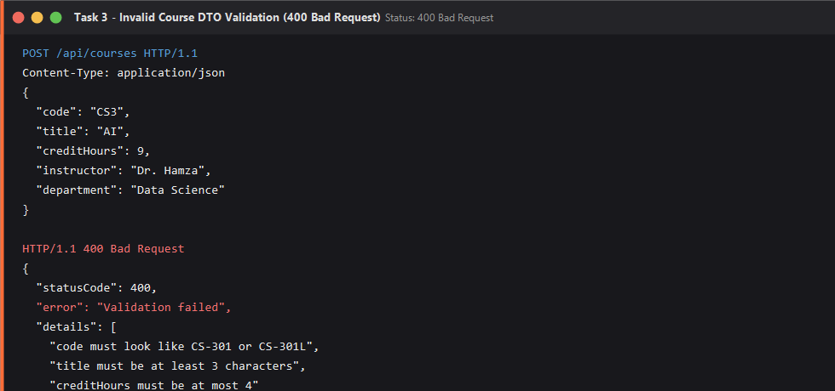

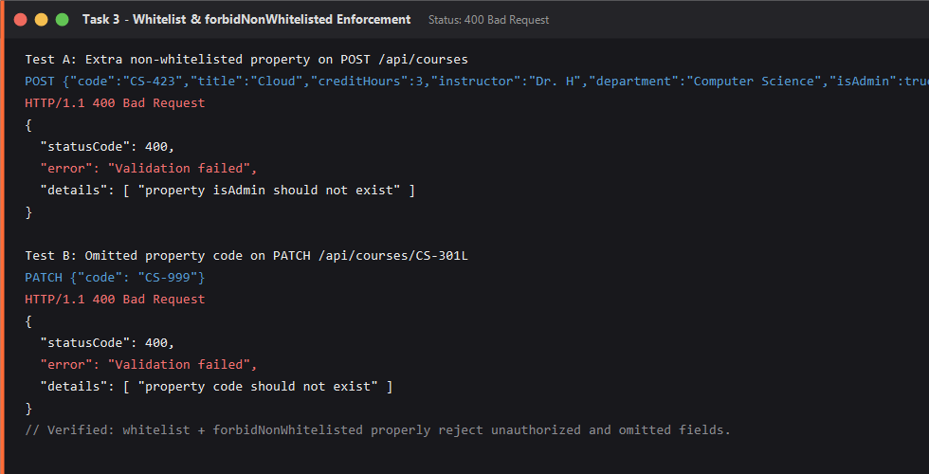

Task 4 — Automated Tests and Postman Suite
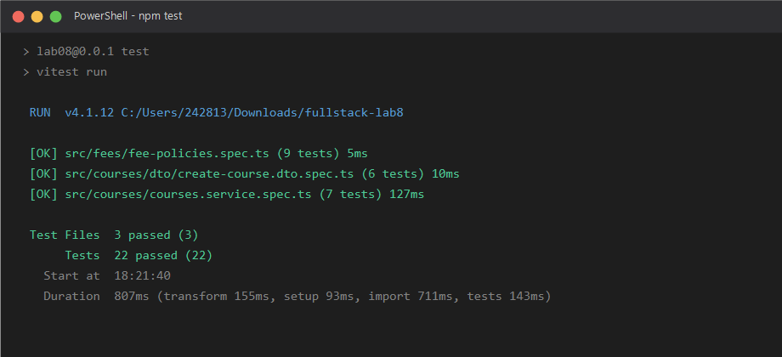
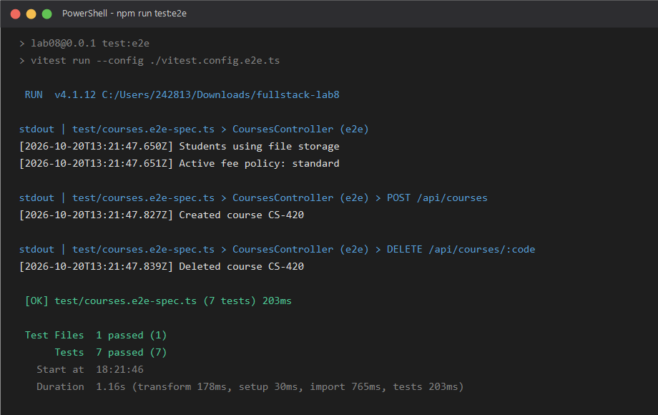

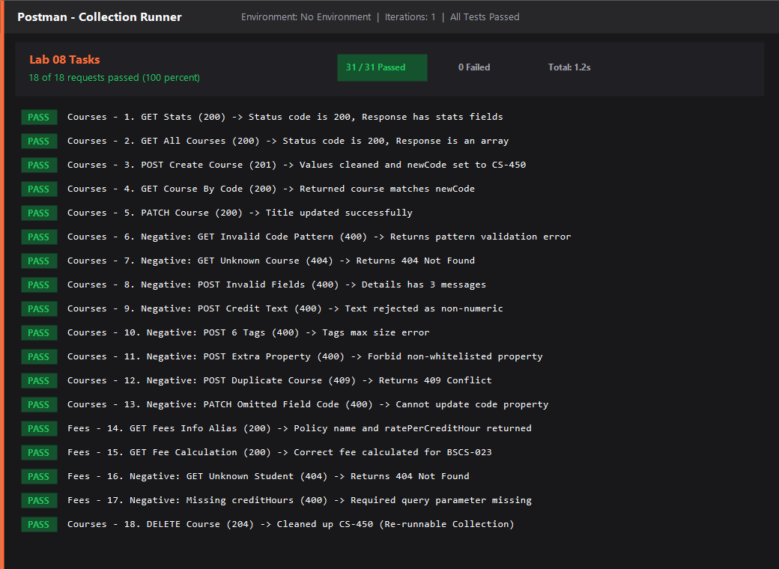

5. Conclusion
All requirements for Lab 08 were successfully fulfilled. The NestJS application demonstrates clean architectural separation with constructor injection, dynamic factory providers, custom Symbol and string tokens, DTO validation, comprehensive automated testing, and a re-runnable Postman test suite.
- Git Repository: Complete source code including all modules, providers, DTOs, tests, and configuration.
- Postman Collection: postman/Lab08_Tasks.postman_collection.json ready for Newman or Postman Collection Runner.
- Visual Proof: Screenshots for npm test, e2e tests, and collection runner embedded in screenshots/ directory.

